

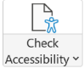
Recommended PowerPoint ADA Checklist
= Manual Task for Faculty/Staff = Accessibility Checker Assisted Task

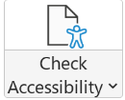


FAU Student Accessibility Services  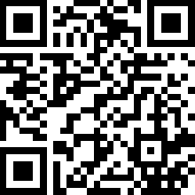 | COM Support  ADA Knowledgebase  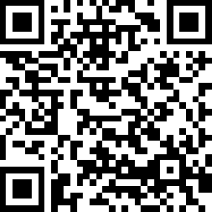 | Microsoft Accessibility Checker Video  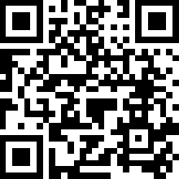 | COM PowerPoint Template Downloads  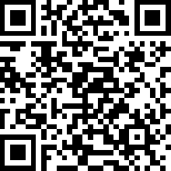 | ADA Appointments with COM Ed Tech  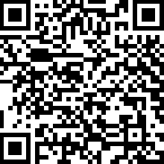 | National Disability Rights Network Guidelines  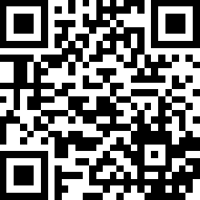
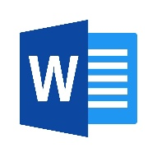
Recommended Word Document ADA Checklist
= Manual Task for Faculty/Staff = Accessibility Checker Assisted Task

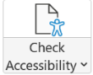

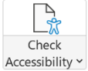

FAU Student Accessibility Services | COM Support  ADA Knowledgebase | Microsoft Accessibility Checker Video  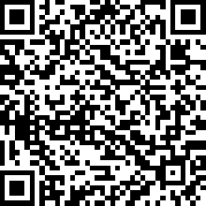 | ADA Accessibility Instructions for Documents  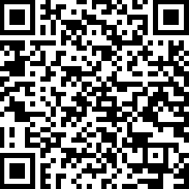 | ADA Appointments with COM Ed Tech | National Disability Rights Network Guidelines

