**COM Ed Tech Recommended ADA Checklist**

**\*Indicates Accessibility Checker Assisted Task**

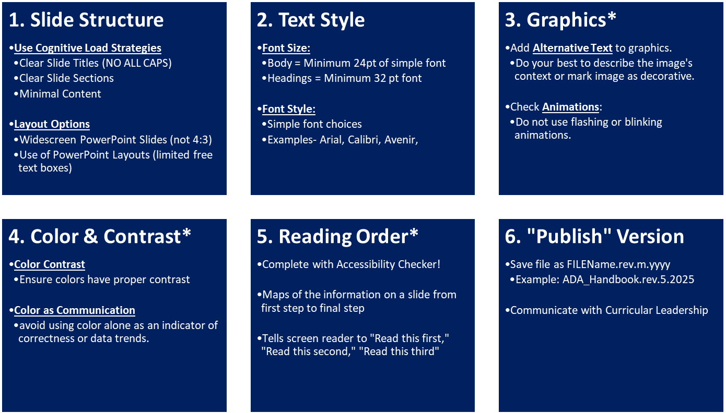

**Resources**

[**FAU Student Accessibility Services**](https://www.fau.edu/sas/accessibility-requirements/)

[**Office365 Accessibility Checker Video**](https://support.microsoft.com/en-us/office/video-check-the-accessibility-of-your-document-9d660cba-1fcd-45ad-a9d1-c4f4b5eb5b7d)

[**COM PowerPoint Templates**](https://comsupport.fau.edu/kb/articles/official-com-powerpoint-templates)